**Use Case:** Trigger Alarm

**Essential Use Case:**

**Participants:** Homeowner, Command Center

**Pre-conditions:** The system is armed.

**Actor Intentions System Responsibility**

5. Enter safety verification

1. A sensor detects an issue that requires attention.

2. Determines system is in away mode.

3. Responds with correct alarm timing

4. Asks for safety verification

6. Contact Emergency Services

**Exceptions:**

2. Determines system is in home mode and immediately triggers the alarm.

5. The user does not enter the correct verification and the alarm is immediately triggered.

**Exceptions:**

2. Determines system is in home mode and immediately triggers the alarm.

5. The user does not enter the correct verification and the alarm is immediately triggered.

**Post Condition:** The alarm is correctly triggered.

**Scenario:**

The system detects an issue from a sensor and begins to trigger the alarm. If in away mode, the user will have a short amount of time to enter their information before the alarm is triggered. Otherwise, the alarm is triggered and the Contact Emergency Services sequence begins.

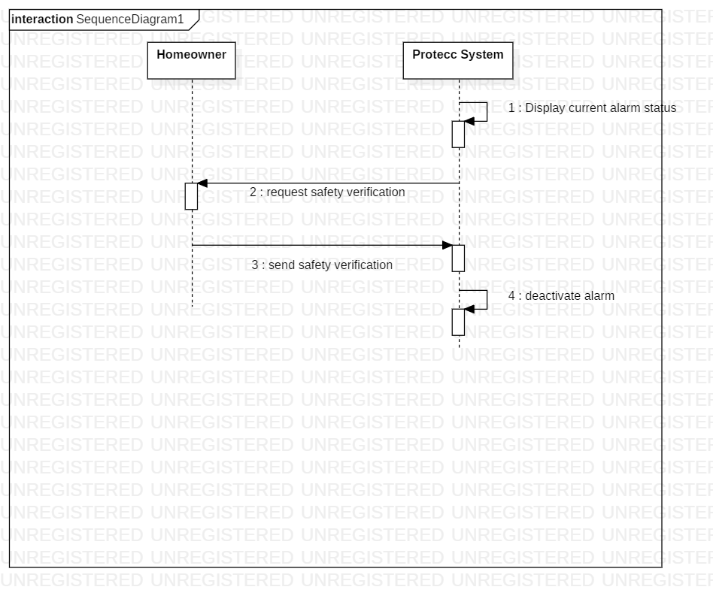

**Concrete Use Case:**

**Use Case Name:** Trigger Alarm

**Entry Condition:**

1. A detector is tripped while the system is activated.

**Flow of events:**

2. The Protecc Command Center determines that the system is armed and releases a warning that the alarm is about to be triggered.

3. The system asks for the homeowner’s personal information to verify the homeowner is safe and not in danger.

4. The homeowner does not enter their correct information within the allotted amount of time.

5. The system triggers the alarm and waits for further instructions.

**Exit Condition:**

6. The system starts the Contact Emergency Services sequence.

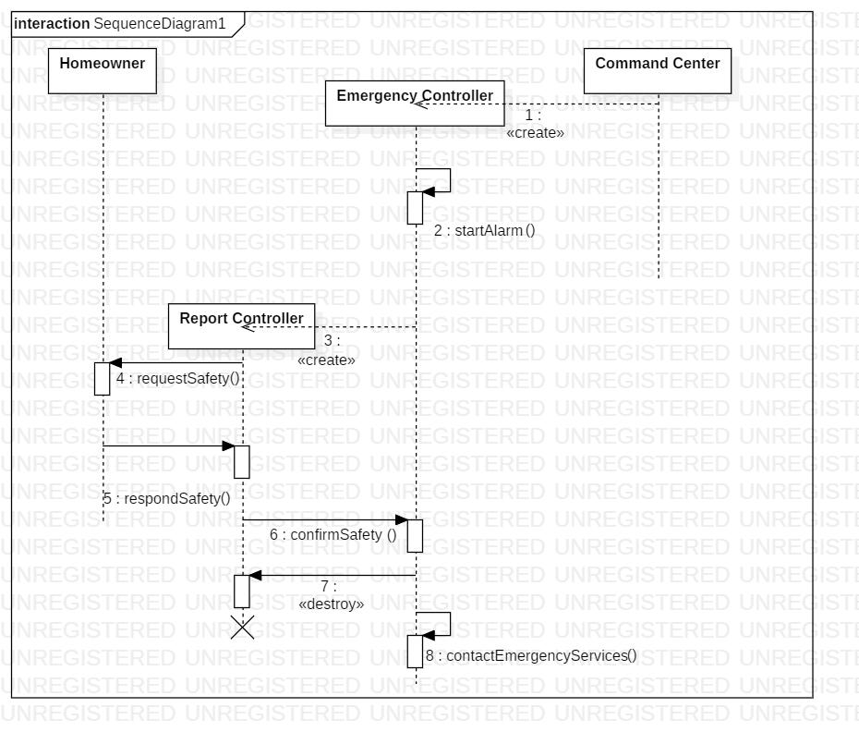

**Use Case:** Turn off Alarm

**Essential Use Case:**

**Participants:** Homeowner, Command Center

**Pre-conditions:** The alarm is triggering.

**Actor Intentions System Responsibility**

3. Replies that the home is safe.

1. Displays current alarm status.
2. Requests verification of safety
3. Alarm is deactivated.

**Exceptions:**

3. Homeowner does not reply that they are safe, and the alarm is not deactivated.

**Post Condition:** Alarm is turned off.

**Scenarios:**

1. If the alarm is triggered and the system is in away mode, the system will warn the homeowner about the alarm. The homeowner has a short amount of time to disable the alarm otherwise it will be set off. The homeowner then has to correctly enter their information in order to deactivate the alarm.



**Concrete Use Case:**

**Use Case Name:** Turn off Alarm

**Entry Condition:**

1. A detector had been tripped while the system was activated, and the alarm was triggered.

**Flow of events:**

2. The Protecc System displays its current status and that the alarm is triggered.

3. The system asks for the homeowner’s personal information to verify the homeowner is safe and not in danger.

4. The homeowner enters their correct information.

5. The system disables the alarm.

**Exit Condition:**

6. The system resets to an unarmed state.

